Insert password that meets requirements:
Attempt | Input | Expected | Actual | P/F
1 | blank | Incorrect length | Incorrect length | P
2 | testingggg | Needs uppercase | Needs uppercase | P
3 | Testingggg | Needs a number | Needs a number | P
4 | Testinggg1 | Needs a special character | Needs a special character | P
5 | Testingg1! | Password valid | Password valid | P

Attempt 1 screenshot:
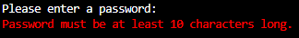

Attempt 2 screenshot:
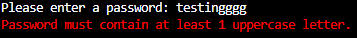

Attempt 3 screenshot:
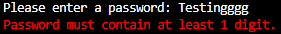

Attempt 4 screenshot:

Attempt 5 screenshot:
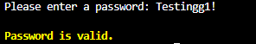

Entering an ip address:

Attempt | Input | Expected | Actual | P/F
1 | blank | Invalid ip | Invalid ip | P
2 | 19216801 | Invalid ip | Invalid ip | P
3 | 192.168.0.one | Invalid ip | Invalid ip | P
4 | word | Invalid ip | Invalid ip | P
5 | 192.168.0.1 | Valid ip | Valid ip | P

Attempt 1 screenshot:
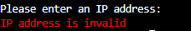

Attempt 2 screenshot:
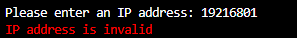

Attempt 3 screenshot:
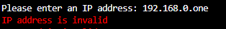

Attempt 4 screenshot:
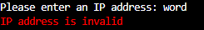

Attempt 5 screenshot:
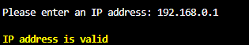

IP and Password correct:

Attempt | Input | Expected | Actual | P/F
1 | Both don’t meet requirements | Attempt again | Attempt again | P
2 | Password doesn’t meet requirements | Attempt again | Attempt again | P
3 | Ip doesn’t meet requirements | Attempt again | Attempt again | P
4 | Both meet requirements | Prompt to run program again | Prompt to run program again | P

Attempt 1 screenshot:
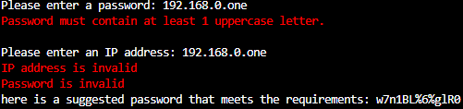

Attempt 2 screenshot:
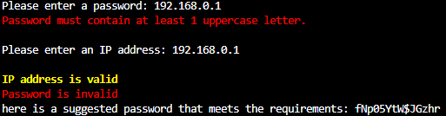

Attempt 3 screenshot:
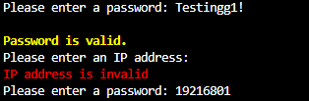

Attempt 4 screenshot:
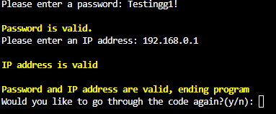

CTRL + C:

Attempt | Input | Expected | Actual | P/F
1 | Keyboard – CTRL + C | Program end | Program end | P

Attempt 1 screenshot:


